Nicolas Huber: 2506144

Question 1:

Task1:

Answer: We can see that the message “Nicolas” is successfully sent form the sender to the receiver:

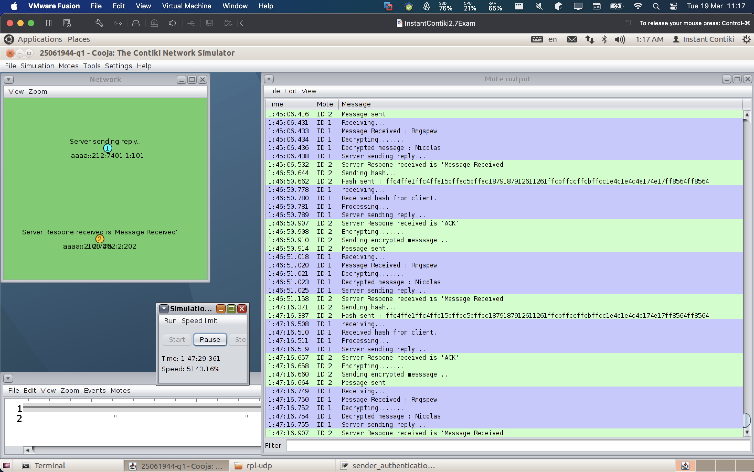

Task2:

Answer:

* Showing the hash value sent by the client 🡪 1:47:16:387
* Showing the encrypted message received by the server 🡪 1:47:16:750
* Showing the message decrypted by the server 🡪 1:47:16:752
* Showing the original message sent by the client 🡪 1:47:16:754

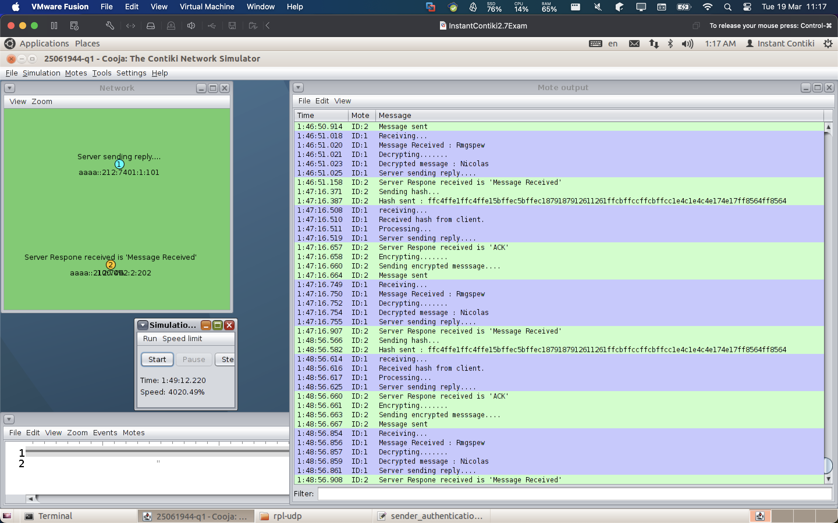

Task3:

Answer: We can see that the client identity is changed successfully and both sender and reciever have adapted the code.

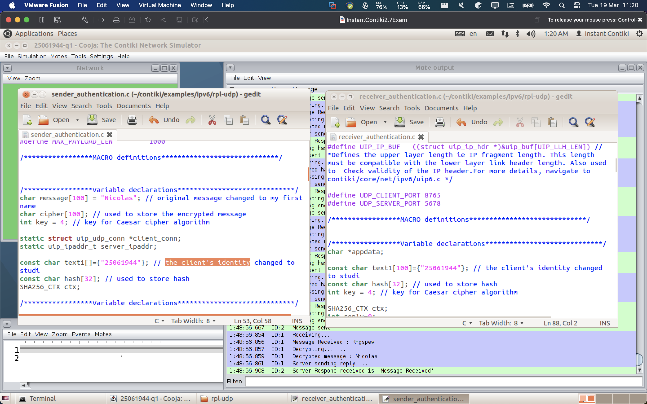

Task4:

Answer: we can see the encrypt function of the sender on the left, and we can see the decrypt function of the receiver (server) on the right.

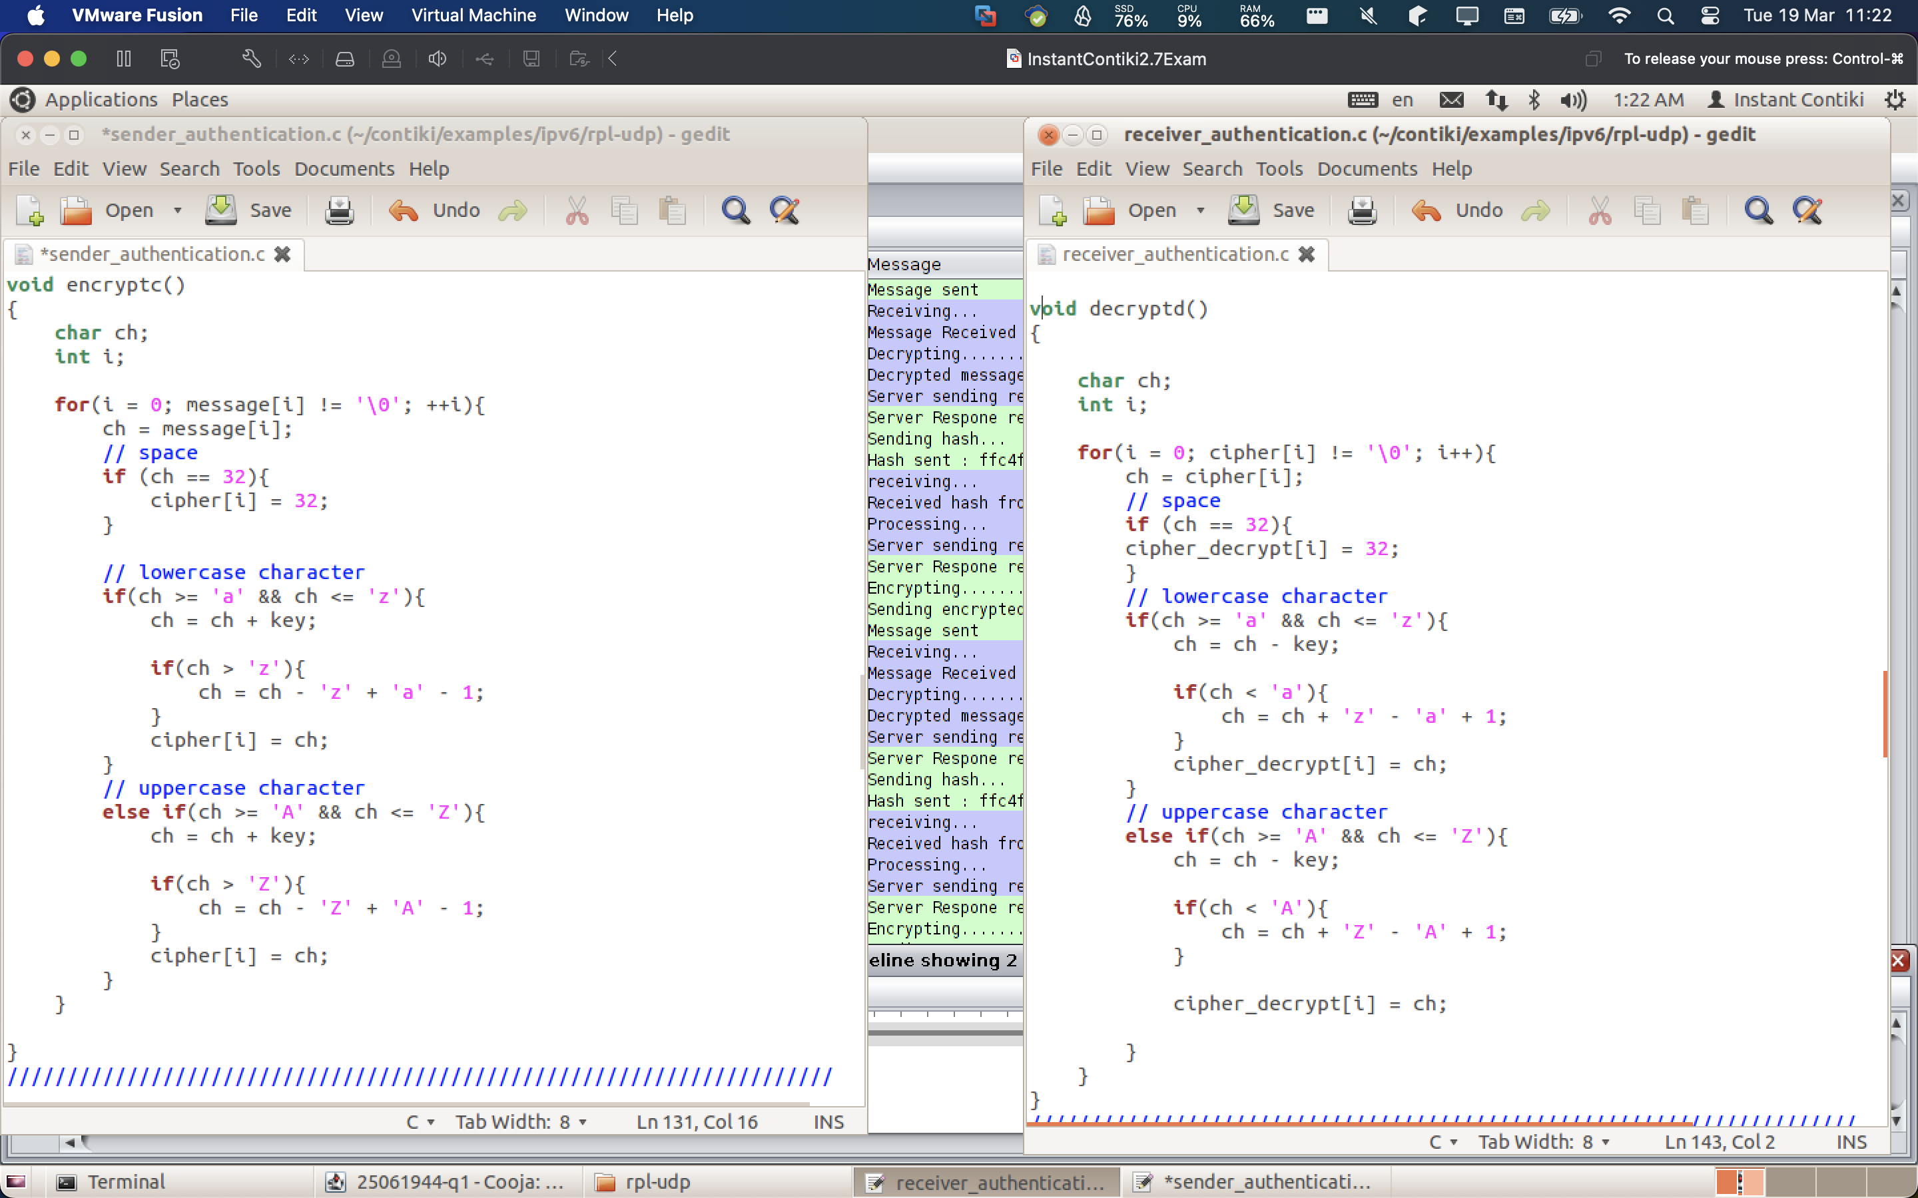

Question 2:

Task 1:

Answer: We can see that the simulation is successfully running and that we exchange messages.

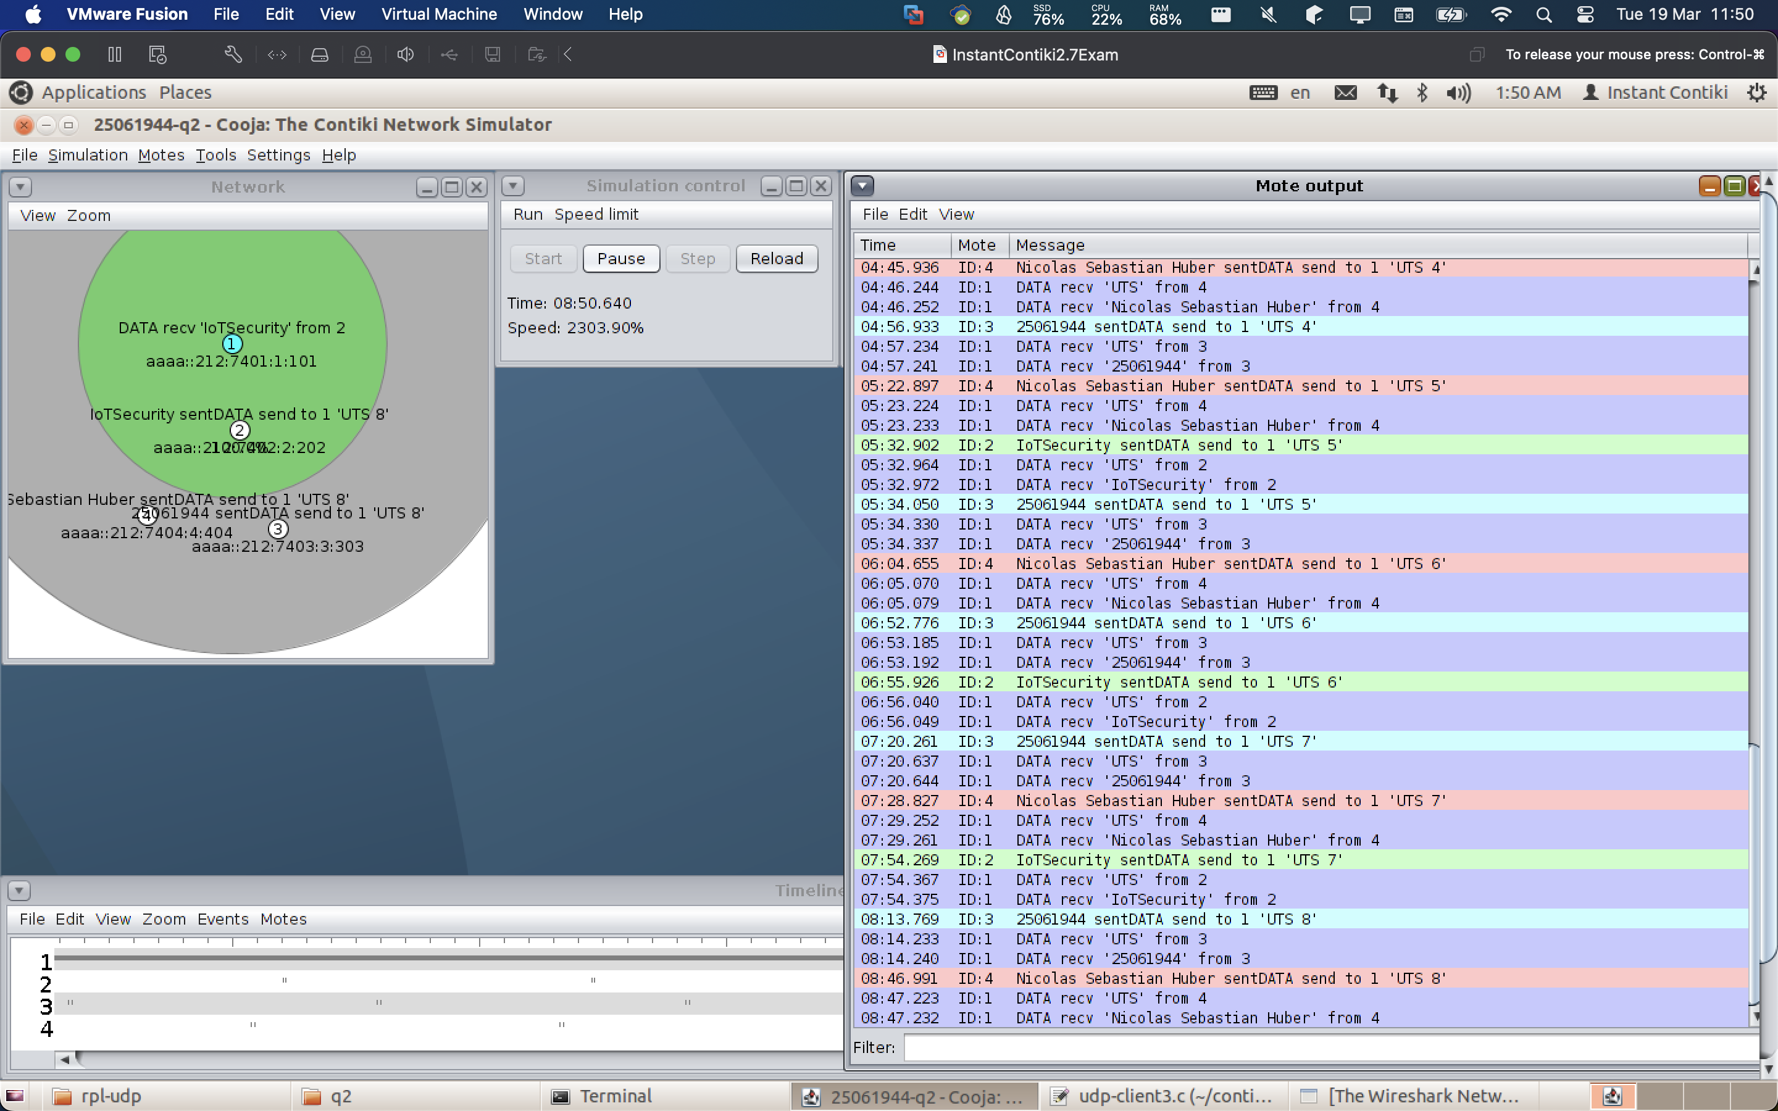

Task 2:

Make all the Clients send the message **“UTS”** to the server. Provide the screenshots showing the required messages that are**sent by the Clients**: **8%**

Anser: We can see that all clients (2, 3, and 4) are sending “UTS” and that the server receives the data.

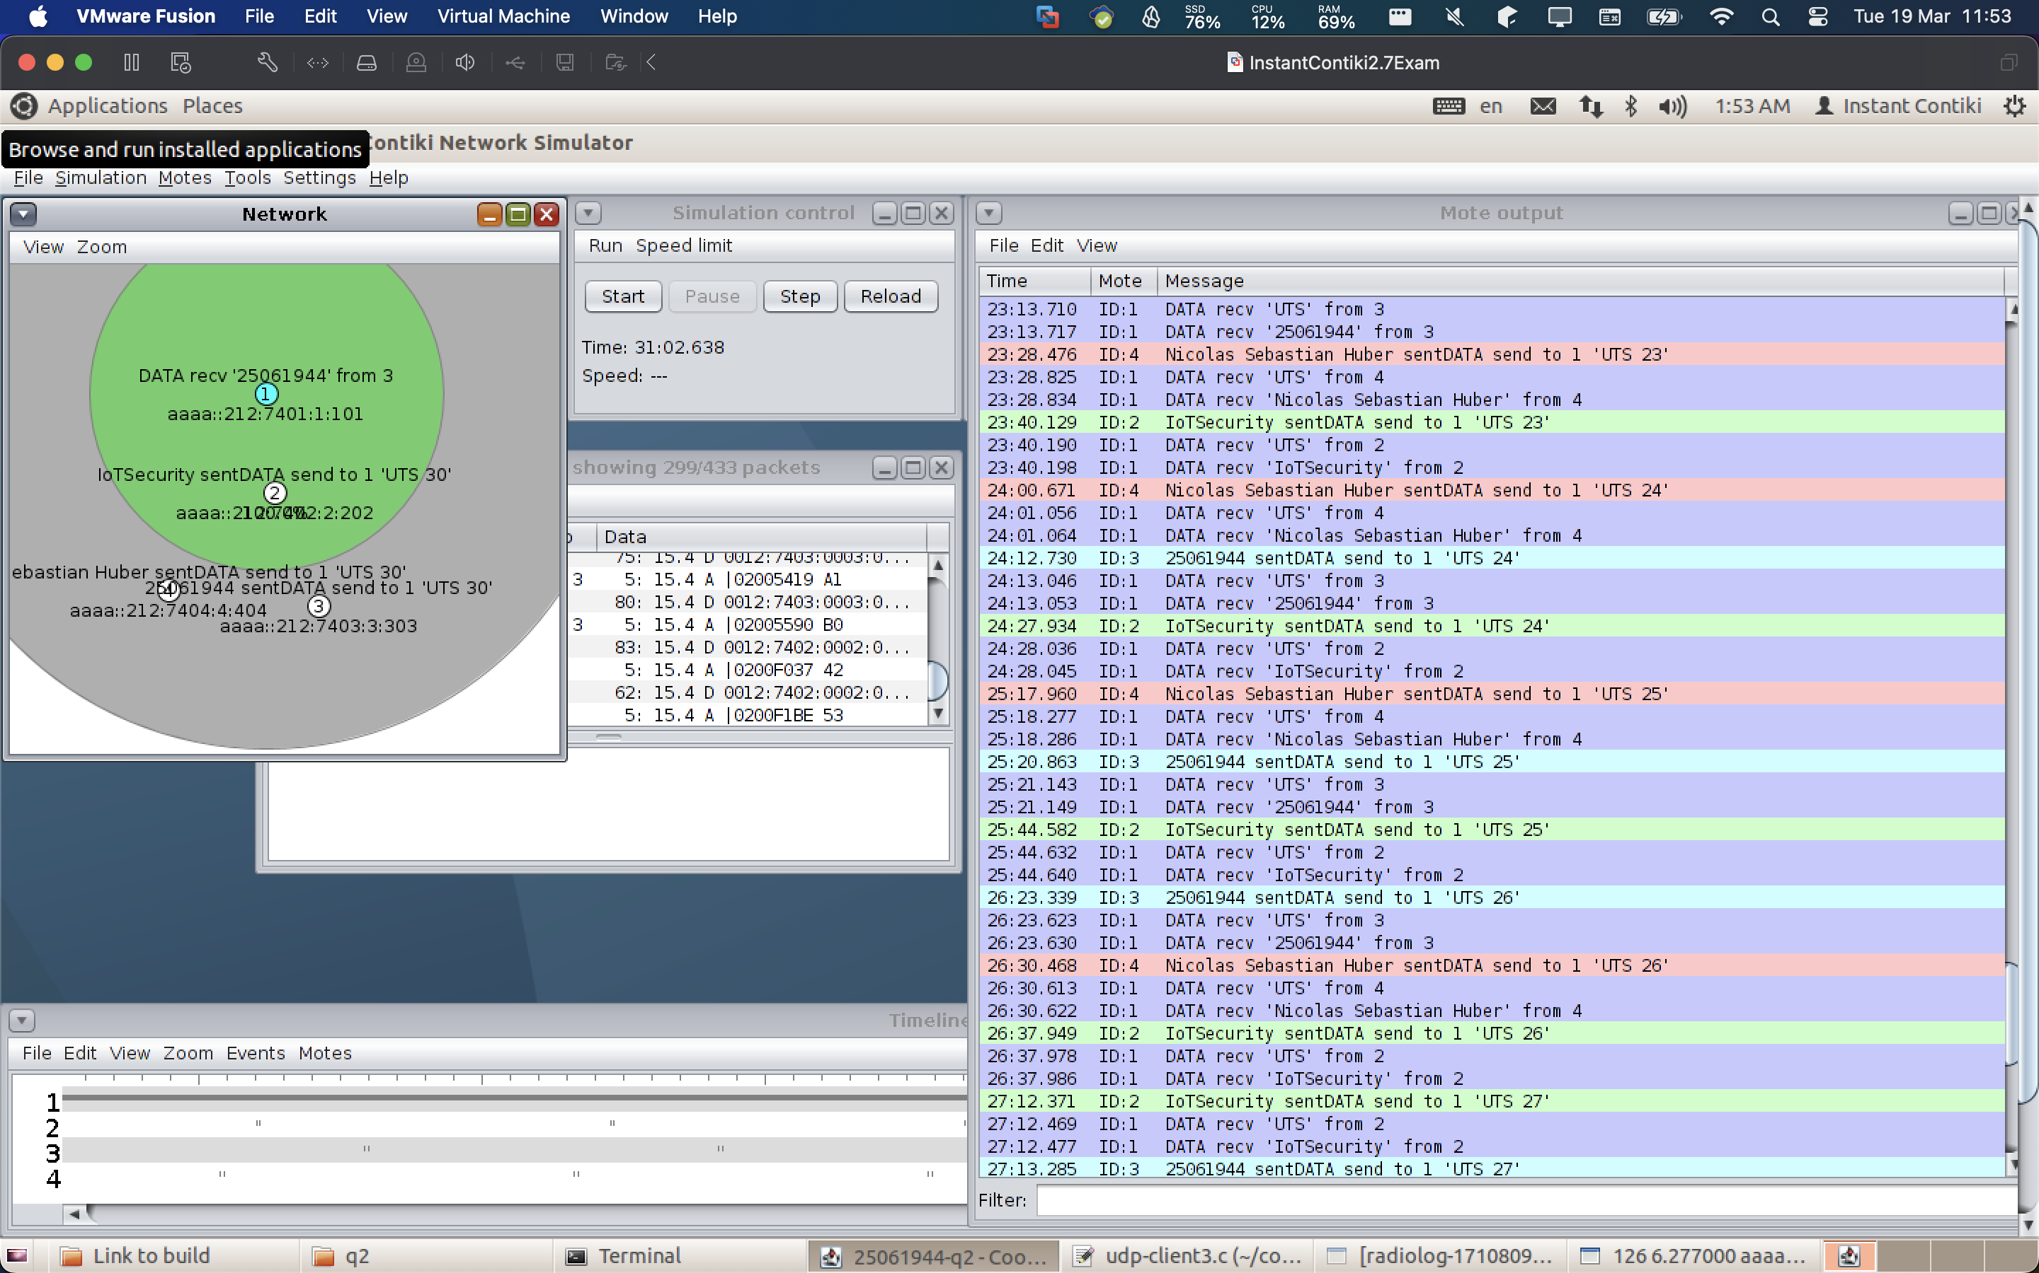

Task 3:

Make Client 1 send **“IoTSecurity”**message, Client 2 send **your student ID** message, and Client 3 send **your full name** to the Server. Provide screenshots showing the required messages **received by the Server** (the receiver): **8%.**

Answer: We can see that all clients (2, 3, and 4) are sending “their corresponding messages” and that the server receives the data via the log:



Task 4:

Answer: We can export the pcap file and open it in Wireshark to inspect the network messages. We can see and inspect the “IoTSecurity” message from the corresponding client.

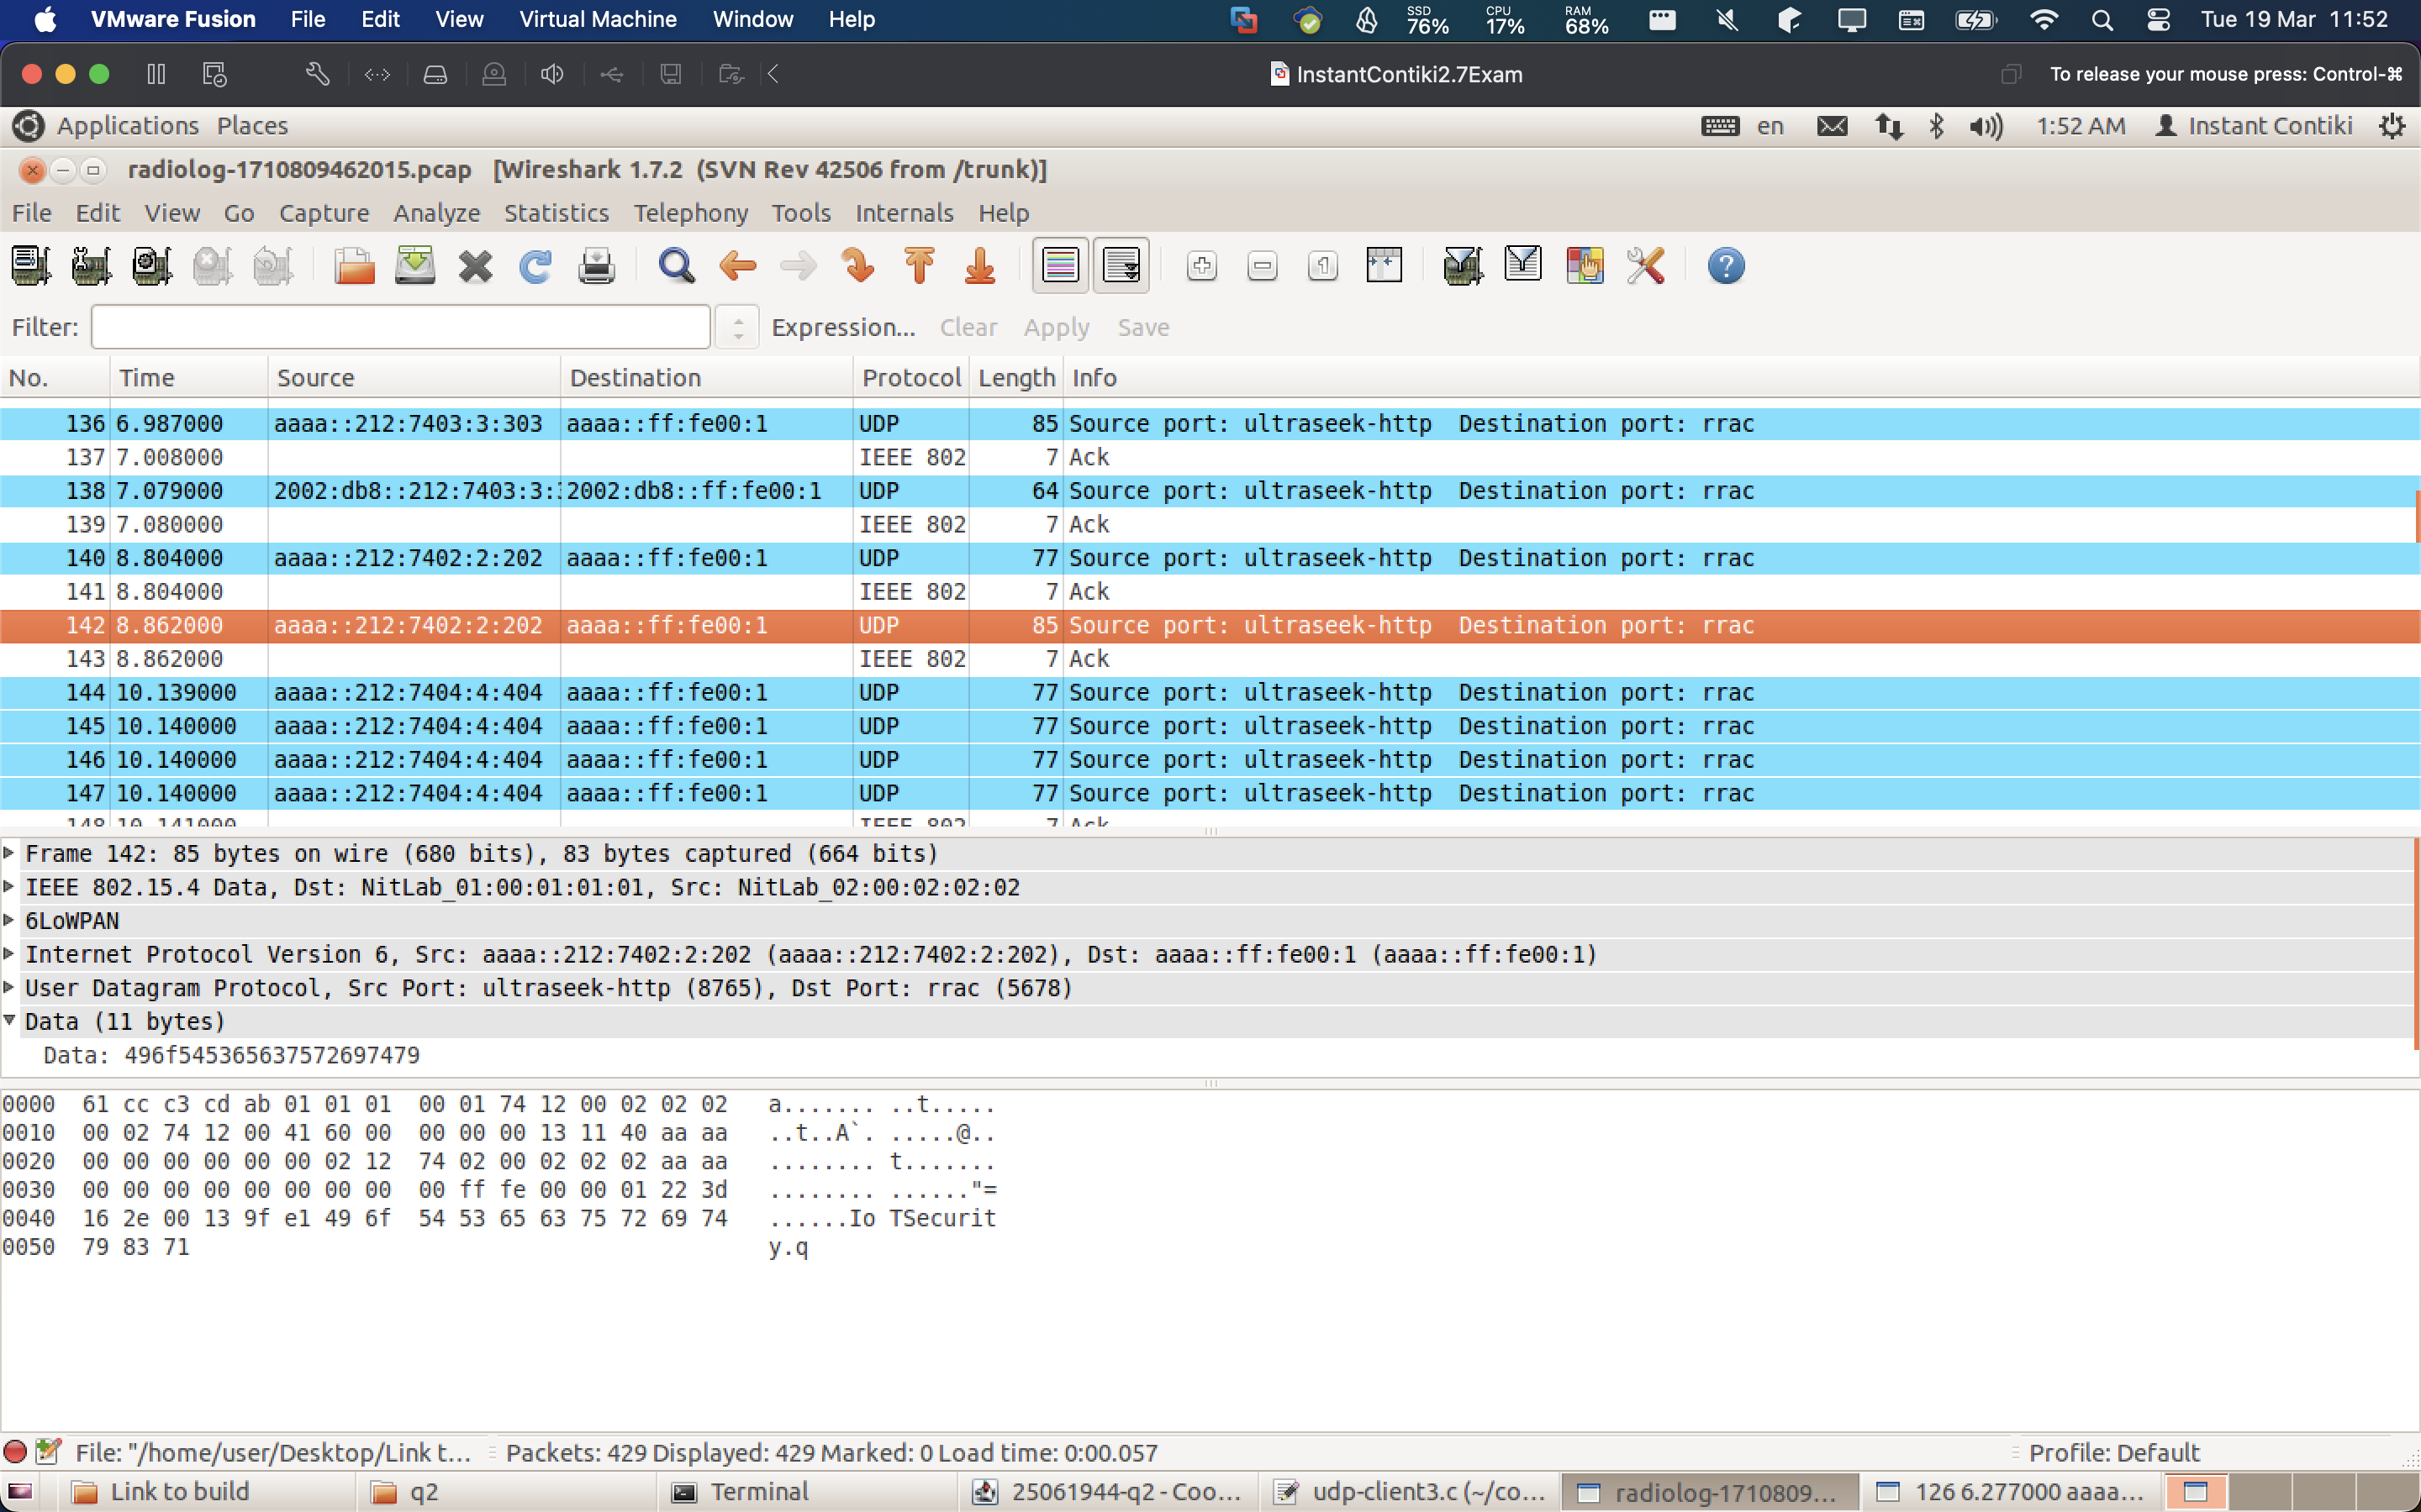

Question 3:

Task 1:

* Can successfully run the simulation (**5%**)

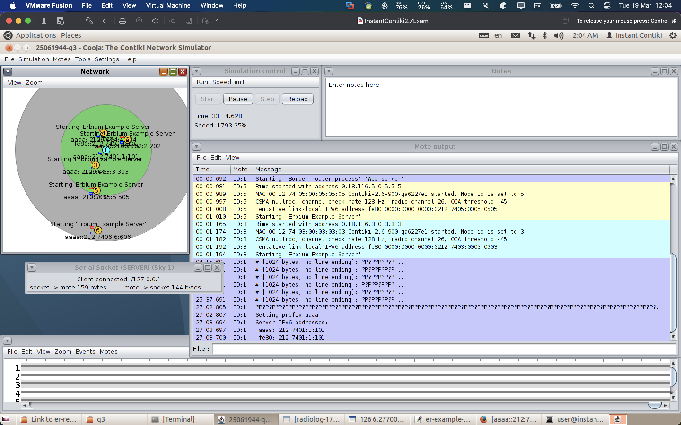

* Use Firefox to see the information of the network, i.e., network topology. Can show the network topology information via Firefox (**5%**)

See the following screenshots:

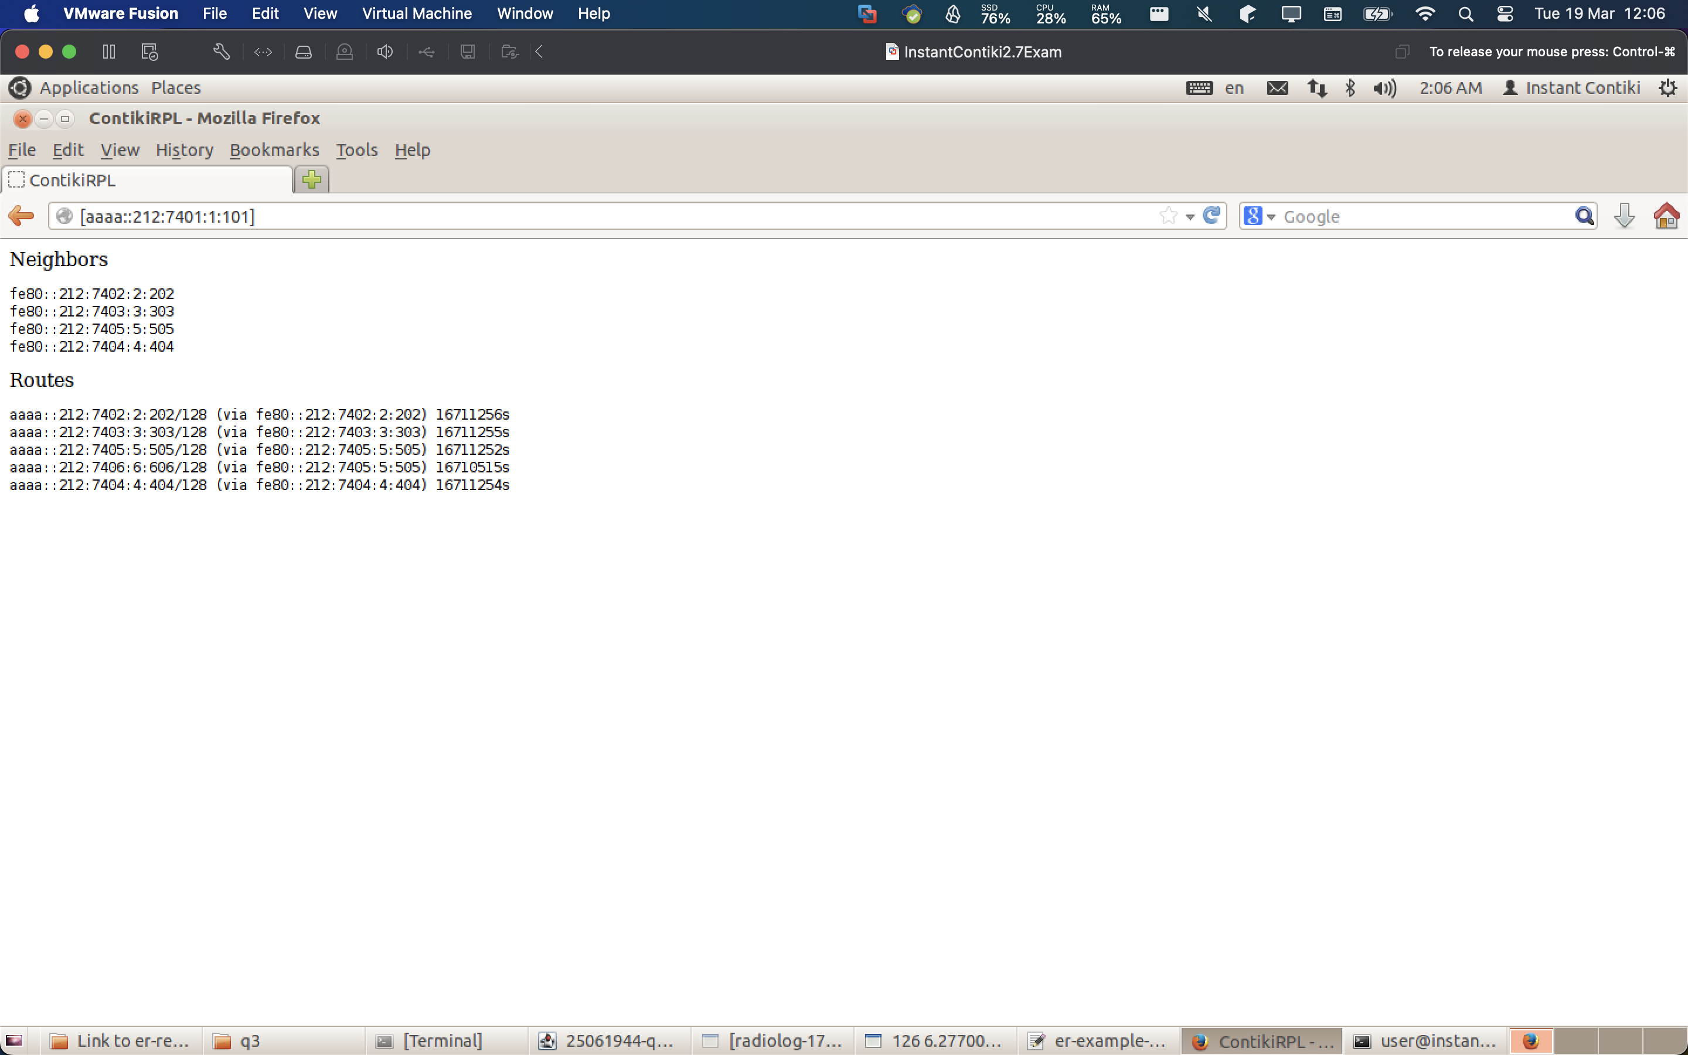

* Use Firefox to remotely control the **LED RED** and**LED BLUE** on the **CoAP server 5 (mote 6)**. Can show the LEDs controlled by the actuator on Firefox and the LEDs of the sky mote 6 on Cooja (**5%**)

This is on node 2: we can control it and use post request to control the leds, since it is in range:

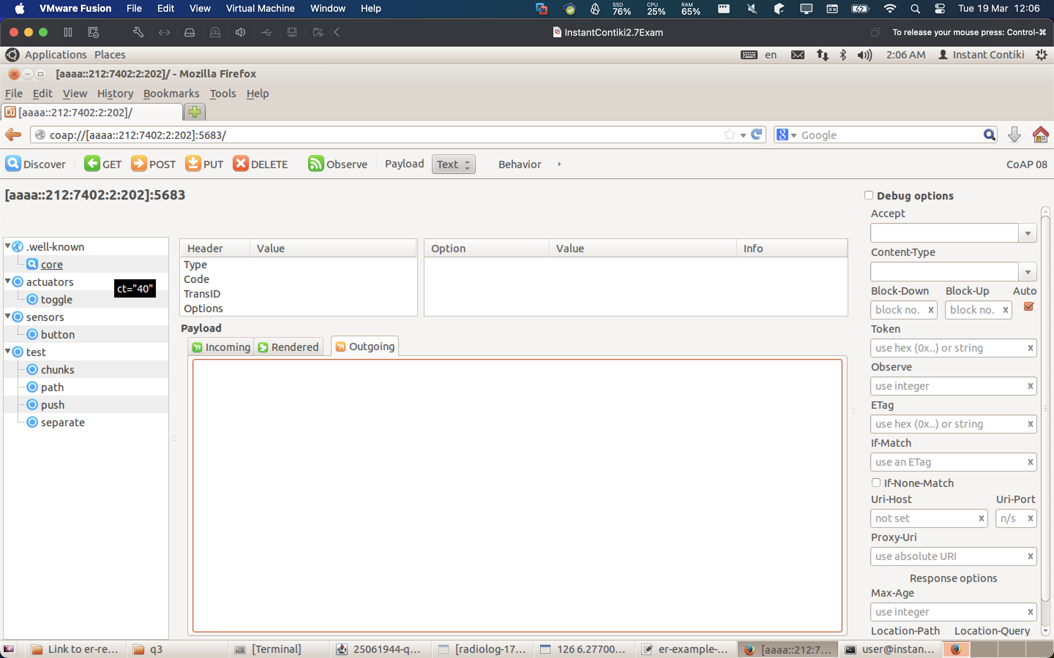

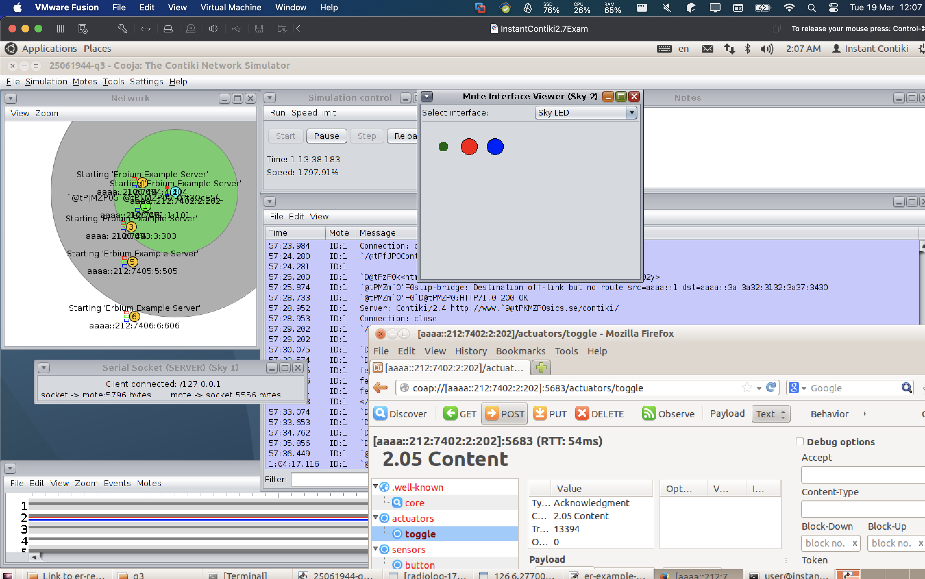

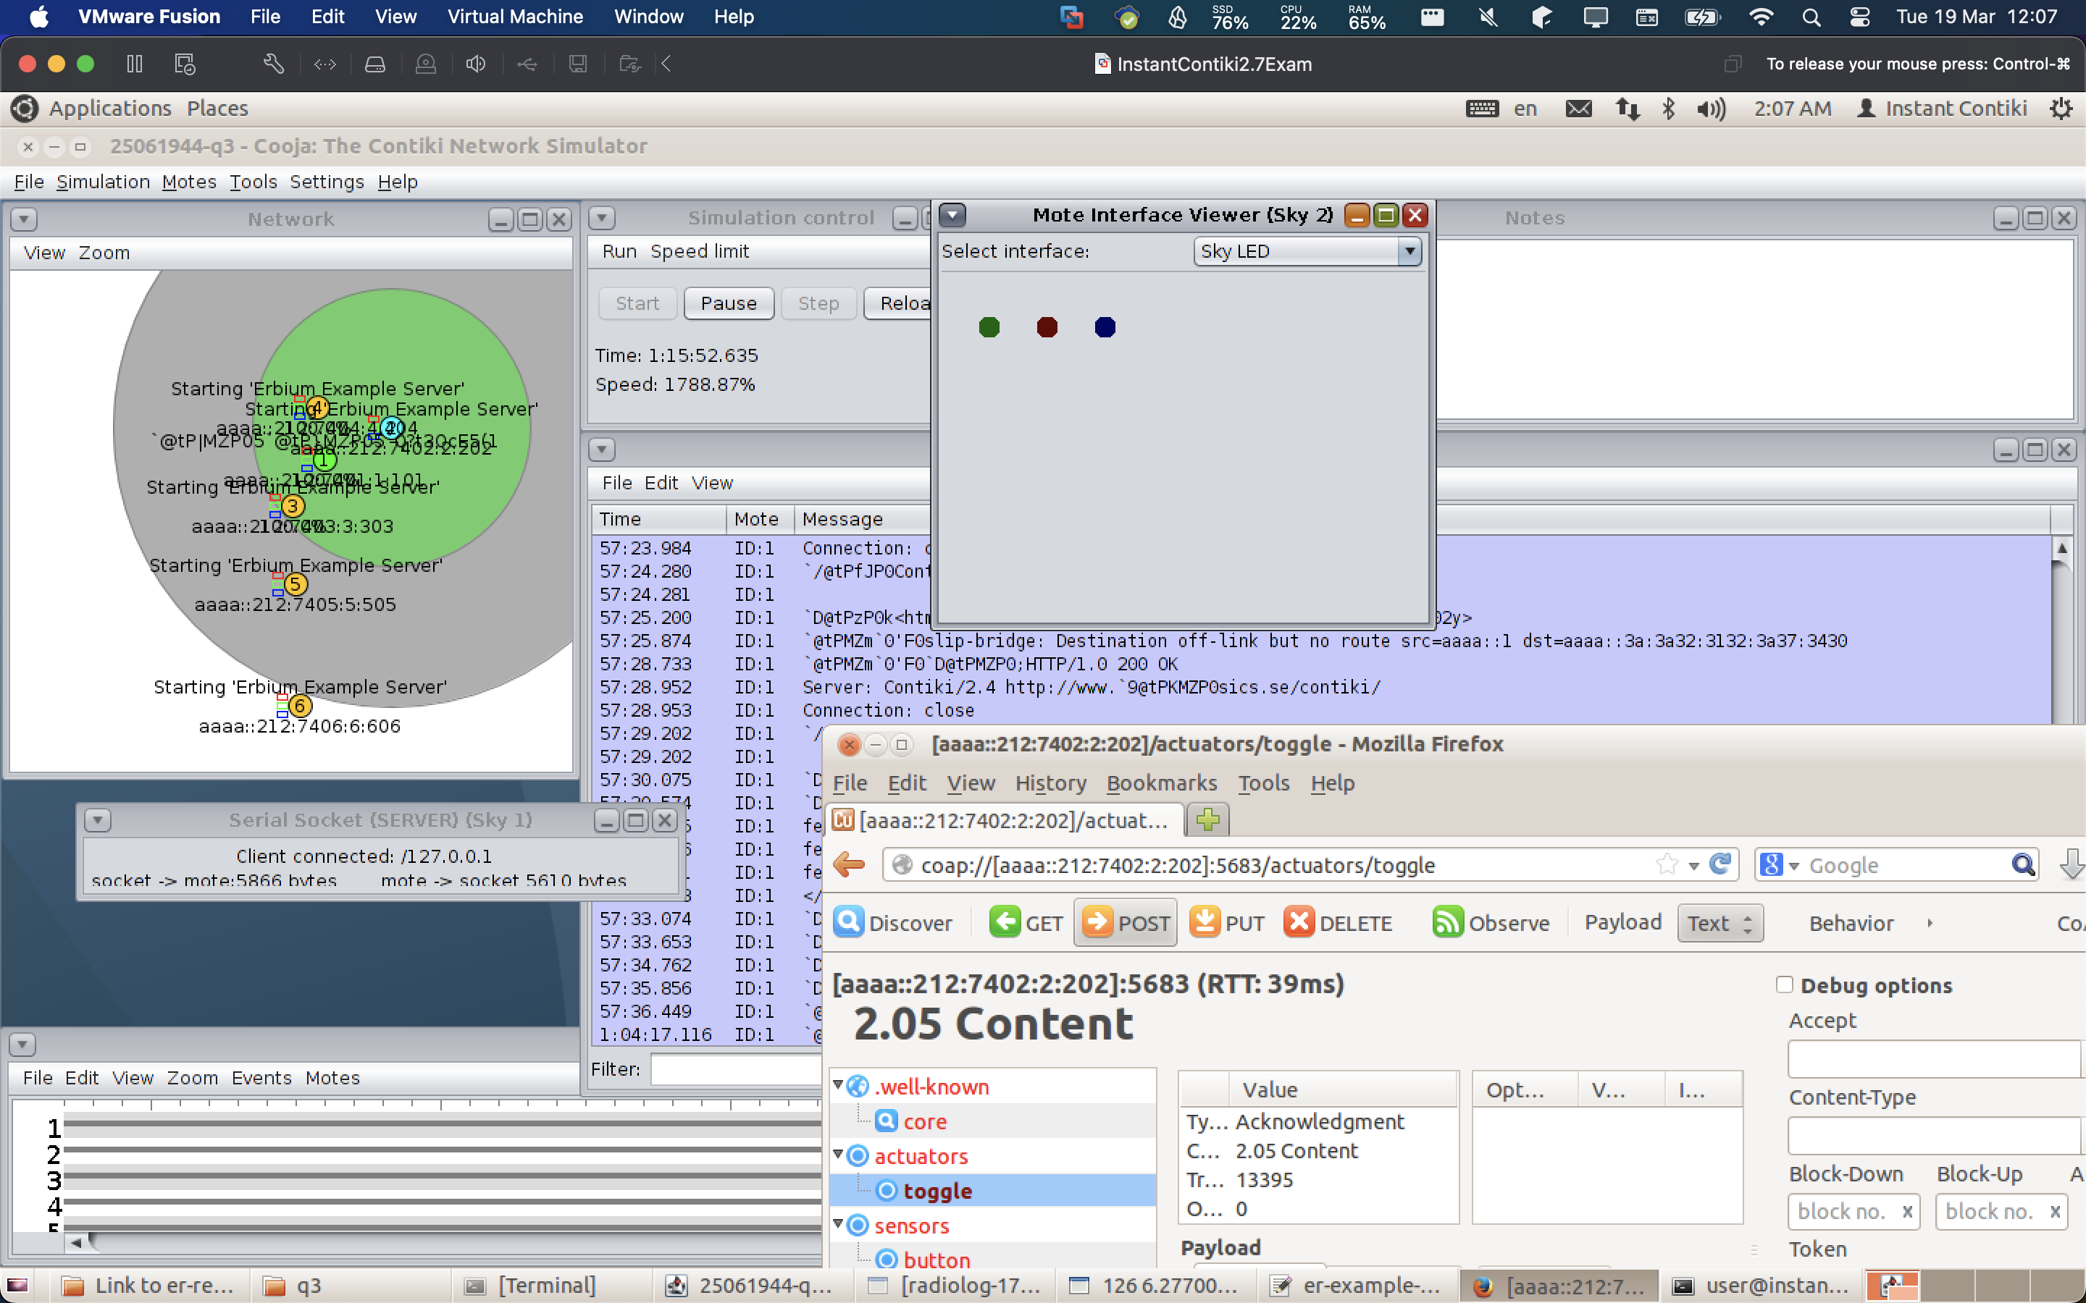

* Use Firefox to remotely control the **LED RED** and**LED BLUE** on the **CoAP server 5 (mote 6)**. Can show the LEDs controlled by the actuator on Firefox and the LEDs of the sky mote 6 on Cooja (**5%**)

Not working for Server 6 because not in range!

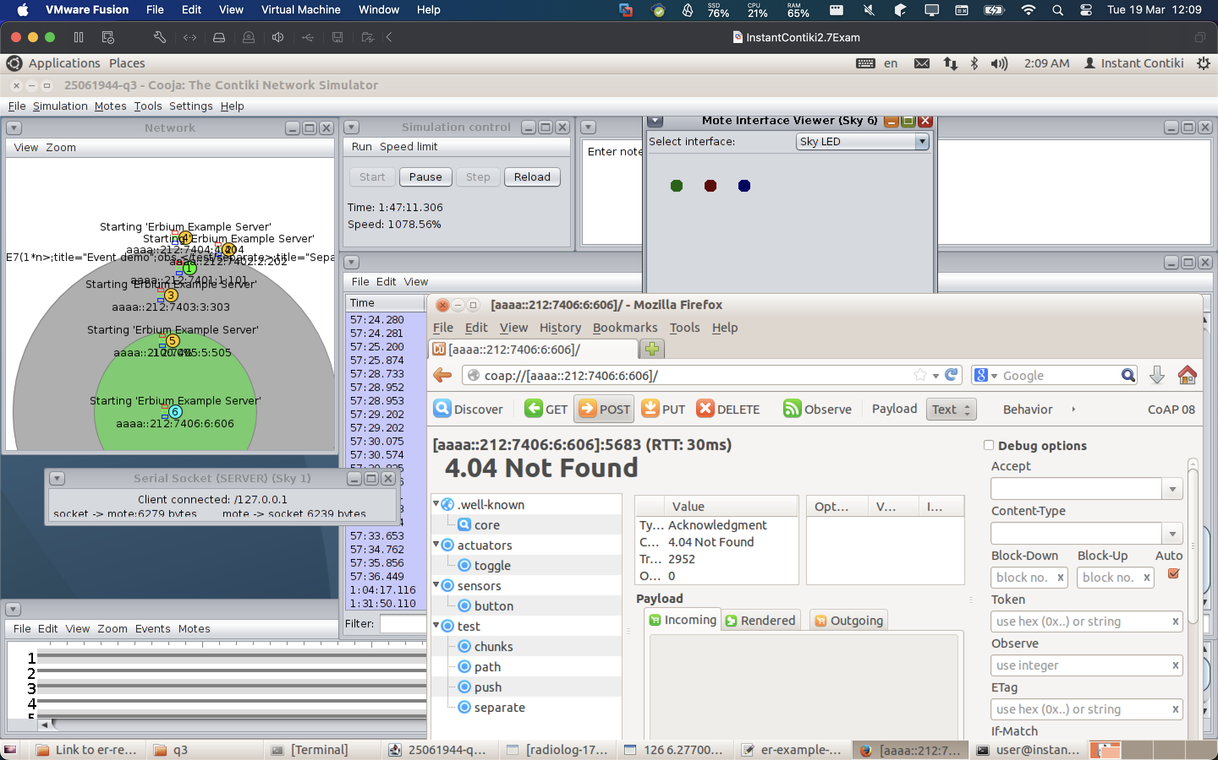

Task 2:

Answer: I added a new udp server as requested:

